I T SYSTEM LOG ANALYZER
Mridul Sharma, Mayank kumar, Vikas Yadav, Sunil Kumar
Computer Science Department, KIET Group of Institutions,
Delhi – NCR, Ghaziabad, U.P. India
mridul.2226ec1195@kiet.edu
mayank2226it1206@kiet.edu
vikas2226cs1213@kiet.edu
sunil.kumar@kiet.edu

Abstract- In Today world the growing infrastructure; this project propose the designing and development of an it system log analyzer develop in python. The mechanism that was established to gather the data and information automatically based on System logs created by it infrastructures. In this project we identify the cybersecurity fuelled approaches and also identify the USER ,LOG IN, changes coming into system and give them into dashboard overview In the current digital world, the log of the system are becoming a primary source of information used to monitor performance, detect and prevent cyber attacks however the logs generated are stored. This project illustrates the need to combine Java flexibility and cybersecurity approaches to construct adaptive and smart log analytics tool of contemporary IT landscape.

Keywords— System Logs, Log Analyzer,
Anomaly Detection, I T Infrastructure,
Machine Learning.
- Introduction
- The procedure to examine computer-produced log events in order to gain an understanding of the well-being and performance of IT surroundings and application is referred to as log analysis. Organizations have been attempting to perform review of logs, on a large scale, since the introduction of computer-generated by records.. However, log is created throughout the IT ecosystem. Others lack all the information that they needed, and are not normally in a compatible format.. In contemporary tools, information is centralized in the process of log analysis and put in the form of easily consumed information. Historical data archive logs could use log analysis as well to draw more insights and modifications. The majority of companies have to save and conduct log analysis within the frames of the compliance requirements.

- background information
Here we review both background information on need as it pertains to the analysis of logs and difficulty with the existing log analysis algorithms..

  - Need for Analysis Logs-

Many Logs are generated by software running on systems to provide information to analyser and system engineer with their analysis of system and get a proper report.

  - Log Analysis Challenges-

The logs are in a form specific to how the program has been built to write entries in these text files. Literature Review

An IT system log analyser refers to a tool that aids organizations and administrators in analysing, monitoring and controlling all the logs that are produced by IT systems, applications, networks and servers.

S.NO. | Name | Title | Disadvantages / Drawbacks
1 | Xu, Wei, Ling Huang, Armando Fox, David Patterson, and Michael Jordan | Large-scale system issues can be detected by mining console logs. | Concentrates predominantly on the runtime issues, not so useful to provide long-term trend analysis.
2 | He, Pingping, Jieming Zhu, Zibin Zheng, and Michael R. Lyu | Experience report: Detection of anomalies by known system logs. | Conventional approaches are no more practical with the amount of logs generated by current distributed systems.
3 | Yuan, Ding, et al | Most of the critical failures can be headed off by simple testing: An analysis of production failures in distributed data-intensive systems. | Assumptions used in studies presupposing failure reproducibility with only three nodes; might not be true in complex modern architecture.
4 | Lou, Jian-Guang, Qiang Fu, Shengqi Yang, Ye Xu, and JiangLi | Mining Invariants of Console Logs to detect System Problems. | Uses consistent deterministic log structures; has problems with log formats that are volatile or dynamic.
5 | Fu, Qiang, James Lou, Yi Wang, and Jiang Li. | Anomaly Detection of Execution in a Distributed System by Unstructured Log analysis. | Detecting execution anomalies by means of unstructured log analysis is a crucial topic of study because of the complexity and scalability of the modern IT infrastructures.
6 | Chuvakin, Anton, Kevin Schmidt, and Chris Phillips | The Official Handbook to the ideas involved in Logging and Log management. | Obsolete compared to new AI-based log analysis techniques.
7 | Zhang, Jieming, et al | Stable Log-based Anomaly Detection of Unstable Log Data. | Historical techniques usually fail because of the assumption of constant log information, which is not the case in reality.
8 | Splunk Inc | The Ultimate Handbook to Machine Data. | The service makes itself effective in handling high amounts of machine-generated data that help organizations draw actionable insights out of their operational data.
9 | He, Pingping, Jieming Zhu, Zibin Zheng, and Michael R. Lyu | Log hub: A Huge Part of System Log Data to AI-driven Log Analytics. | Dataset-based; not exactly suggesting methods of anomaly detection..
10 | Li, Zhenpeng, Min Zheng, and Ding Yuan | The problem and the solution of Log Parsing. | Emphasis on parsing, as opposed to end-to-end log analysis. Parsing programs are fragile, and do not support invisible log formatting.

- Related Work
Research in log analysis span rule – based systems,
Statistical anomaly detects problem and machine learning approach. Commercial SIEM products provide end to end features but it has costly. The open resource tools provide flexible ingestion and search; recent researchers have explored ML to analyze the root cause and to cluster logs.
- Proposed system
AI-based adaptive anomaly detection and predictive analytics can be implemented in the IT System Log Analyzer, which will be used to predict failures even

before they happen. Deep learning and reinforcement enable us to do so. the system itself can keep getting better, learning, whereas federated learning guarantees privacy- maintaining inter-organizational cooperation.

The reason of the problem will be automatically determined knowledge graph and the system will then make a clear decision on their problem in this project where real time monitoring was possible by cloud as the logs came in.
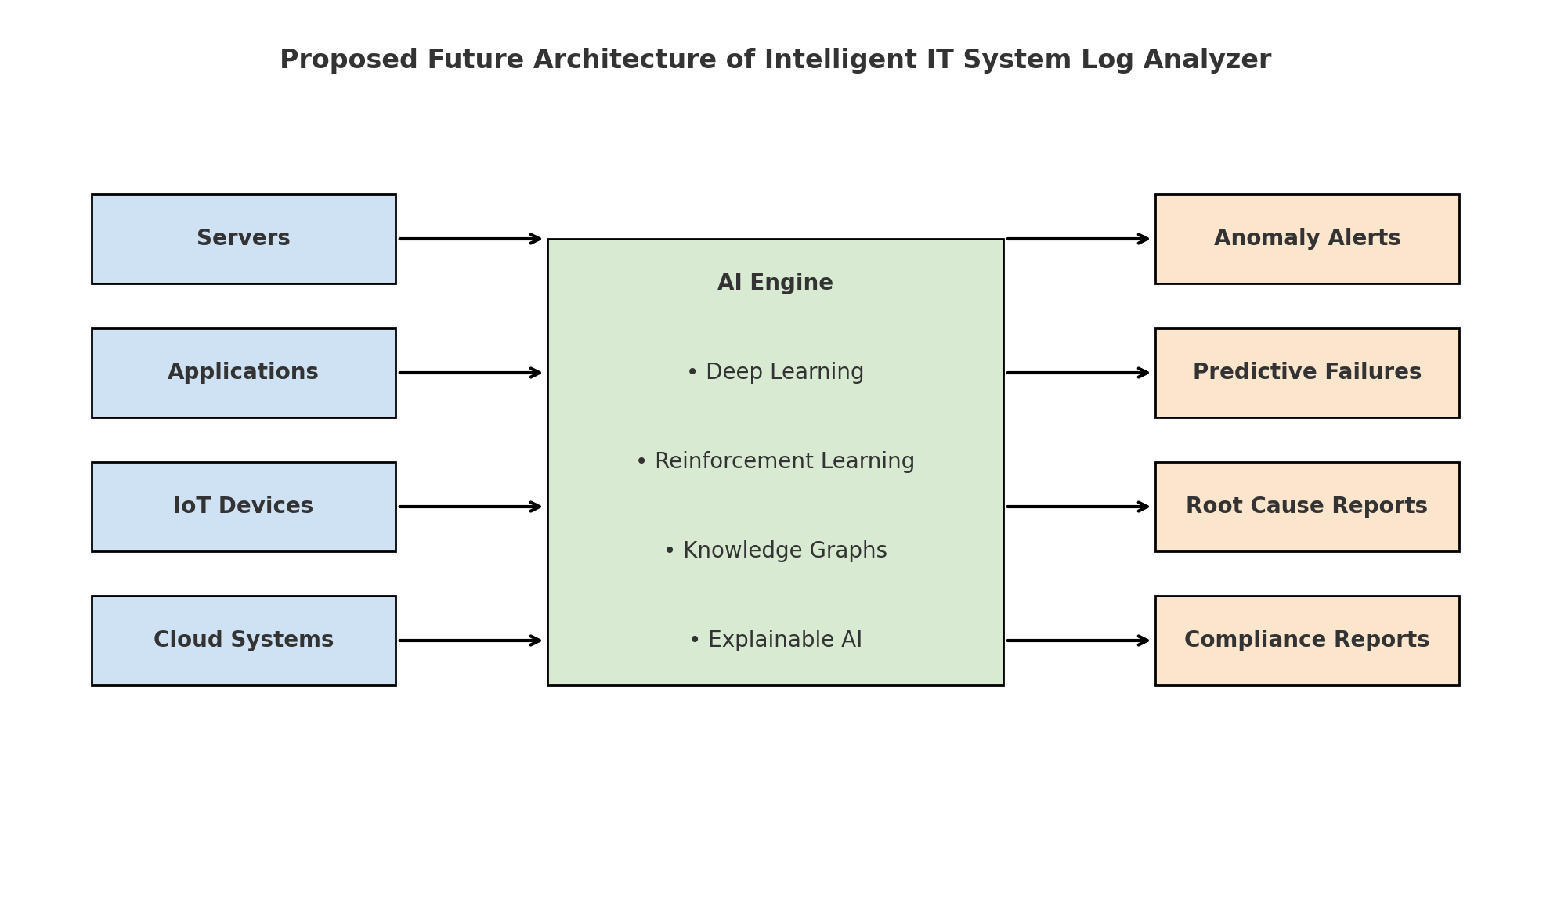

Fig 1. Proposed System of IT System Log Analyzer
- System Architecture

The system contain four main components:
(1) Log Sources
(2) Ingestion & Parsing
(3) Storage & Indexing
(4) Analytics & Visualization.

Logs are collected via system log, agents, or system will generate the log according to command present in python file that will Develop system log then the system log will automatically show on the dashboard of system and analysed with graphs.

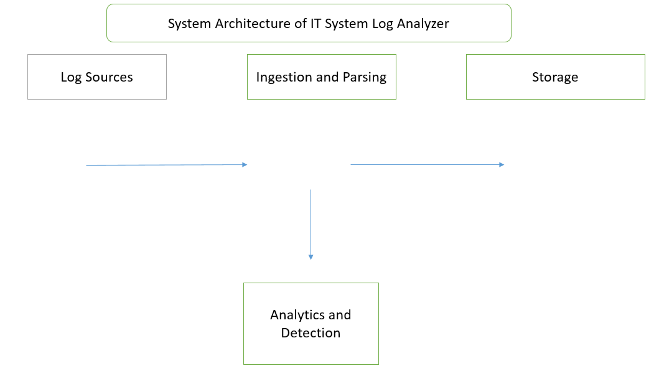
Figure. 2. High Level Archietcture of IT System Log Analyzer
- Gantt charts

We will defined many types of tasks which are perform in IT System log Analyser and representing Visualise through GANTT CHART:-

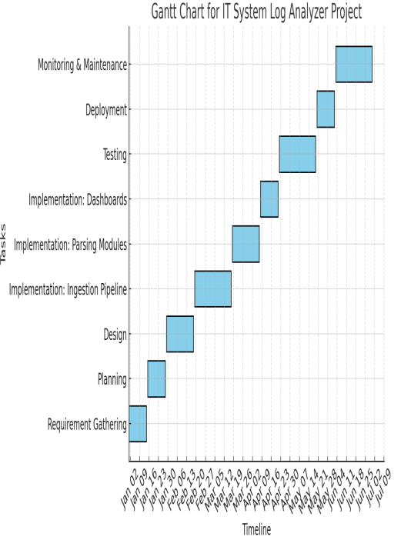

Figure 3. Gantt chart for IT System Log Analyzer
VII. Methodology

Processing/Analysing IT system logs typically undergoes several steps to process, analyzer and process the log data successful.. This methodology will divide into two categories log generation and then analyzing log and prove the charts. Data Collection is Gather log data from various sources. Servers, applications, network devices, databases, and security appliances can be the sources of logs. Use log collection agents, syslog protocols, and APIs to aggregate logs. Collectors of logs are customized. Log Aggregation .Find a central repository to store logs provided by various sources. Normalization, classification and tagging are five common techniques used in the log analysis. The process of cleaning logs so they are bound to the same standards and formats is referred to as normalization. In Pattern recognition the procedure of find the pattern in logs, so that appearance of individual logs can be done in appropriate manner.ly.

A. ALGORITHM

Step 1: Log Collection & Ingestion
- Gather logs of various sources.
- Standardize the data pattern to ease analysis.
- Retrieve inventories in a storage facility..

Step 2: Log Pre - processing
- Remove Irrelevant Messages by Cleaning
- Logging: extract Fields in a Log.
- Normalize Time Stamps to the Same Format, Error Codes & Severity Level to Normalise

Step 3: Data Indexing & Storage
- Parsed Log Messages stored in a Structural Format in a Database.
- Parameters in search: Indexing log entries that can be quickly searched with parameters of: timestamp, log type and IP Address among others.

Step 4: Log Analysis
- Searching Log Messages using Queries, to Find Patterns like Number of Failed Logins or Response Time.
- Statistical Analysis by Count of Frequencies of a Single Error and a Time-Varying Data Analysis.

Step 5: Correlation
Correlate Log Entries and All Systems to identify Multi-System Attacks.

Step 6: Alerting & Reporting
- Establishing Unusual activity limitations.
General sked: Producing Alerts in case of Exceedance of Thresholds.

Step 7: Feedback Loop
study false positives and/or false negatives to be used as a way of refining detection rules...

B. FLOWCHARTS
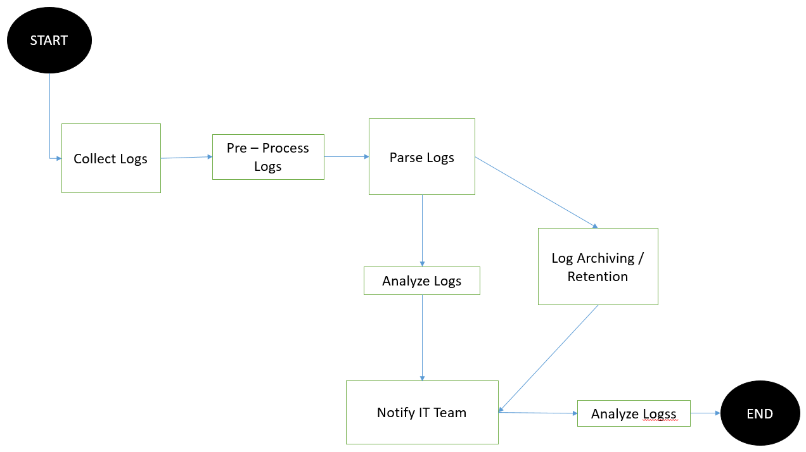
Figure 4. Flowchart of IT System Log Analyzer
- RESULTS

In our sample run, the system was able to process logs with a throughput of up to 180 logs/min and was able to detect the logs.
words with high recall with injected anomalies. Below are representative visualizations.

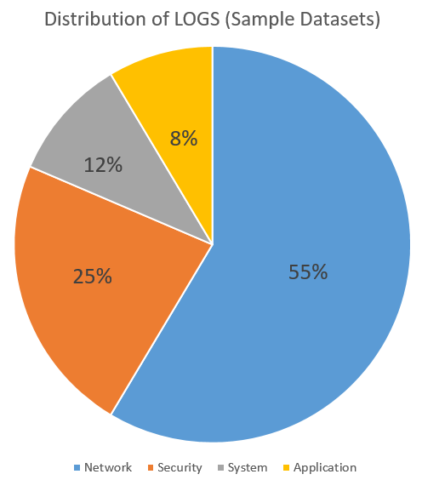

Figure 5. Distribution of log types in the sample dataset

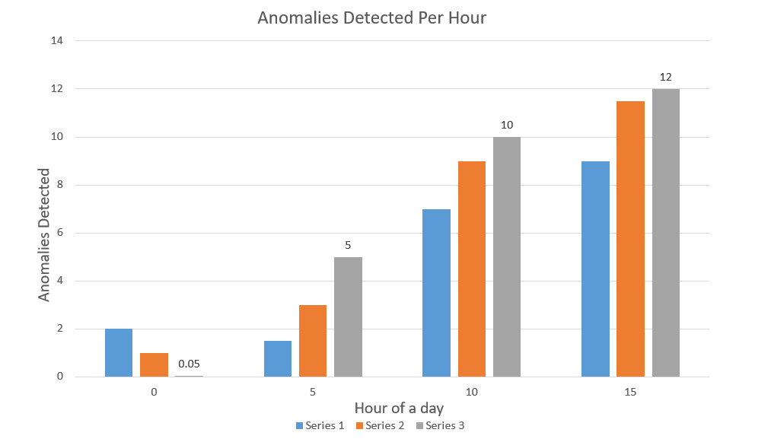

Figure 6. Anomalies detected per hour (sample run).

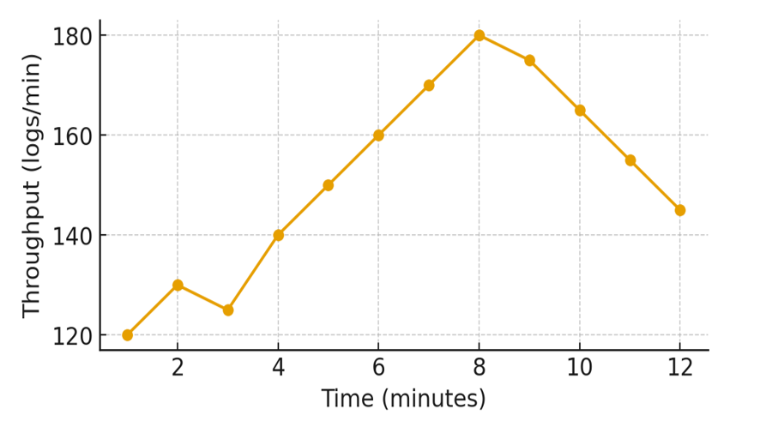

Figure 7. Log processing throughput over time (sample)

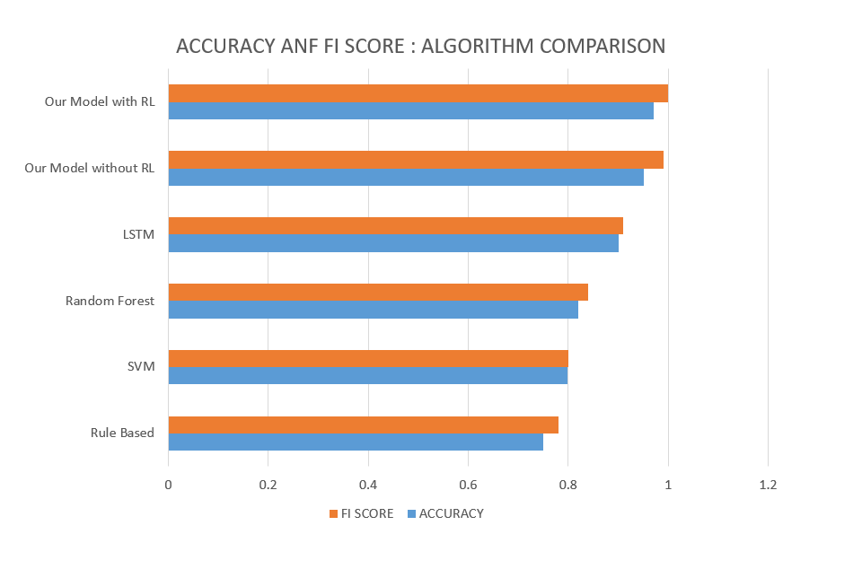

Chart 1. Algorithm Performance Comparison (with and without Reinforcement Learning)

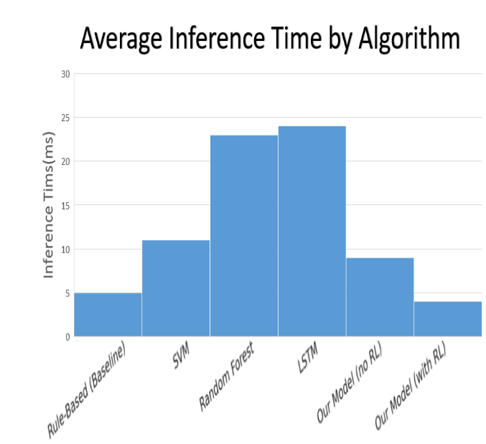

Chart 2. Average Inference time by Algorithm with our Model

- Conclusions
THE ITSLOGANA is a standalone application used to manage the security, performance and reliability of IT systems. THE PLATFORM (ANALYZER) It Will eventually be deployed with different perks and outcomes when it comes to successfully deconstructing logs. BETTER SECuring threats ID and responding. THE ANALYZER is customised to gather and match logs that have been analysed information gathered by variant sources in case to identify patterns or exceptions that could be indicative of a system getting compromised. IT Can identify noxious activity attempts that include unauthorized access and malicious security Incidents by scanning logs of firewalls, server, and application. This is proactive in terms of identifying risks and halting of production running in its operations helping to streamline and shortening downtimes. The LOG ANALYZER can be used to perform the collection and processing of performance logs and system events to identify problem areas in the system, bottlenecks in its performance and so on as well as the errors that might have played a role in causing a crash. THIS ENTITLES IT INDUSTRY regulates and norms. Lots of industries have required data logging and audit trails. Thanks to the log analyzer that records all the essential actions undertaken by the system, compliance can be confirmed. CompLIance with Industry stipulations ANALYZER-AUTOMATION of reportings and alerts help to provide companies with documentation on audits, and assist compliance with Industry regulations. INFORMED decision-making and strategic planning. THIS SOLUTION is adding VISUAL INSight to Your Log Data and Making Reports on your behalf. Such lessons can empower the IT administrators and managers to make informed decisions regarding system upgrades, capacity planning and resource scheduling. Historical logs are also used to analyse patterns and future projections in the past needs of requirements.

- References
[1] W. Xu, L. Huang, A. Fox, D. Patterson, and M. Jordan, “Detecting large-scale system problems by mining console logs,” in Proc. 22nd ACM SIGOPS Symp. Operating Systems Principles (SOSP), 2009.
[2] P. He, J. Zhu, Z. Zheng, and M. R. Lyu, “Experience report: System log analysis for anomaly detection,”
[3] D. Yuan et al., “Simple testing can prevent most critical failures: An analysis of production failures in distributed data-intensive systems,” in Proc. USENIX Symp. Operating Systems Design and Implementation (OSDI), 2014.
[4] J.-G. Lou, Q. Fu, S. Yang, Y. Xu, and J. Li, “Mining invariants from console logs for system problem detection,” in Proc. USENIX Annu. Tech. Conf. (ATC), 2010.
[5] Q. Fu, J. Lou, Y. Wang, and J. Li, “Execution anomaly detection in distributed systems through unstructured log analysis,” in Proc. IEEE Int. Conf. Data Mining (ICDM), 2009.
[6] A. Chuvakin, K. Schmidt, and C. Phillips, Logging and Log Management: The Authoritative Guide to Understanding the Concepts Surrounding Logging and Log Management. Burlington, MA, USA: Syngress, 2012.
[7] J. Zhang et al., “Robust log-based anomaly detection on unstable log data,” in Proc. 2019
[8] Splunk Inc., The Essential Guide to Machine Data. Splunk White Paper, 2014.
[9] P. He, J. Zhu, Z. Zheng, and M. R. Lyu, “Log hub: A large collection of system log datasets for AI-driven log analytics,” in Proc. IEEE Int. Symp. Software Reliability Engineering Workshops (ISSREW), 2019
[10] Z. Li, M. Zheng, and D. Yuan, “Log parsing: Challenges and solutions,” ACM Queue,2021.
[11]W. Xu, L. Huang, A. Fox, D. Patterson, and M. Jordan, “Detecting large-scale system problems by mining console logs,” in Proc. 22nd ACM SIGOPS Symp. Operating Systems Principles (SOSP), 2009.
[12] P. He, J. Zhu, Z. Zheng, and M. R. Lyu, “Experience report: System log analysis for anomaly detection,”
[13] D. Yuan et al., “Simple testing can prevent most critical failures: An analysis of production failures in distributed data-intensive systems,” in Proc. USENIX Symp. Operating Systems Design and Implementation (OSDI), 2014.
[14] J.-G. Lou, Q. Fu, S. Yang, Y. Xu, and J. Li, “Mining invariants from console logs for system problem detection,” in Proc. USENIX Annu. Tech. Conf. (ATC), 2010.
[15] Q. Fu, J. Lou, Y. Wang, and J. Li, “Execution anomaly detection in distributed systems through unstructured log analysis,” in Proc. IEEE Int. Conf. Data Mining (ICDM), 2009.
[16] A. Chuvakin, K. Schmidt, and C. Phillips, Logging and Log Management: The Authoritative Guide to Understanding the Concepts Surrounding Logging and Log Management. Burlington, MA, USA: Syngress, 2012.
[17] J. Zhang et al., “Robust log-based anomaly detection on unstable log data,” in Proc. 2019
[18] Splunk Inc., The Essential Guide to Machine Data. Splunk White Paper, 2014.
[19] P. He, J. Zhu, Z. Zheng, and M. R. Lyu, “Log hub: A large collection of system log datasets for AI-driven log analytics,” in Proc. IEEE Int. Symp. Software Reliability Engineering Workshops (ISSREW), 2019
[20] Z. Li, M. Zheng, and D. Yuan, “Log parsing: Challenges and solutions,” ACM Queue,2021.

